**Safe Recruitment Process**

**Policy and Procedures**

Master Kindred Martial Arts (MKMA Karate)

Written: 7th April 2021

Latest Review Date: July 2026

To Be Reviewed with Intervals No Greater Than 2 Years

**Reviewed last**: 30/07/2024

**Reviewed By:** J. Rowberry

**Signature:**

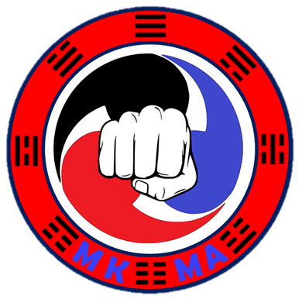

**Safe Recruitment Process**

MKMA Karate are committed to providing a thorough recruitment process to ensure the safe and effective instruction of all our members. Below outlines this process.

1. Student informs instructor they wish to become an instructor and is recommended by their instructor or student is recommended by their instructor and wishes to become an instructor.
2. Student has meeting with the MKMA Chief Instructor/Assistant Chief Instructor/Admin Team to discuss suitability, the application process, and the job role.
3. Student completes the required training outlined in the MKMA instructor application form.
4. *DBS form is completed (Online) and submitted and presented to the MKMA admin team by the student.

**4a)** Should a DBS return conviction, these should be reviewed, and if relevant, a risk assessment put in place. Consider rejection of application.

1. Student submits the MKMA Karate policies sign-off form along with evidence of course completion including safeguarding and first aid.
2. Full application is reviewed by MKMA Admin team
3. Decision Made:

Instructor Applicant

Final approval

Application accepted

Application refused

Gains provisional instructor status

Opportunity to reapply if appropriate

Minimum of four classes Supervised

Instructor card Issued

Feedback given to

applicant

-

**Obtaining a DBS**

*Should the Instructor Applicant already hold a Valid **Enhanced** DBS from another organisation, this can be submitted as evidence so long as it has a minimum of **two** years until expiry. A photocopy of the DBS should be taken and retained by MKMA Karate.

MKMA Karate uses the Online eBulk system utilised by Warwickshire County Council in order to process DBS applications. Warwickshire County council then acts as a counter signatory before your application is processed.

**The Cost**

Due to the nature of martial arts and the close instruction and supervision of children, MKMA Karate require every instructor to hold a valid Enhanced DBS. The cost of a DBS is £40 with a processing cost of £20 meaning a total cost of £60 although this price may vary slightly.

**The Process**

1. MKMA will email you the link and instructions to complete an online application form.
2. An appointment to meet with the MKMA Designated Safeguarding Lead should be arranged by the applicant to check official documents. Photocopies **and** originals of each document should be brought to the meeting.
3. The MKMA Karate DSL will complete the online identity check section of the application and request an enhanced DBS and barring.
4. DBS application will be received, reviewed, and authorised by Warwickshire County Council
5. Full application will be sent off by WCC.
6. Checks will be complete, and certificate sent out to the applicant.
7. Applicant to present original DBS certificate to a member of the MKMA team along with a photocopy.
8. Original retained by individual.
9. Photocopy retained by MKMA Karate.