**Becoming and MKMA Instructor**

**Policy and Procedures**

Master Kindred Martial Arts (MKMA Karate)

Written: 7th April 2021

Latest Review Date: July 2026

To Be Reviewed with Intervals No Greater Than 2 Years

**Reviewed last**: 30/07/2024

**Reviewed By:** J. Rowberry

**Signature:**

Becoming an MKMA Instructor

Whilst you have most likely had to teach parts of a class or an individual student throughout your martial arts journey, becoming an instructor is no small decision. An instructor role is full of responsibility and requires the individual to act on behalf of MKMA Karate upholding its core values at all times.

MKMA instructors are expected to complete certain courses before they will be allowed to independently teach a class. MKMA Karate has chosen these courses to complete as they will not only provide support and guidance in your development as an instructor but will also be useful to develop you as an individual and can be used in your wider life.

Membership and course charges will be paid for by the individual in the first instance. Upon successful completion of all mandatory training a refund maybe issued to the sum of 50% of the total course charges for both the first and second year.

**1. Insurance & Instructor Qualification**

All MKMA Instructors are required as a minimum to have:

* Instructor insurance
* DBS check
* Safeguarding qualification
* First aid certificate (Or agreed equivalent)
* Instructor qualification level 1 from BMABA.

We have tried to make this process as simple and as quick as possible whilst ensuring you have all the necessary skills and knowledge to be an individual instructor. To do this we require all instructors to become a member of the BMABA (British Martial Arts and Boxing Association).

The BMABA provide both membership and insurance as well as many other courses and benefits. Within the BMABA membership, instructors will have access to the required level 1 Instructor qualification as well as a multitude of other resources which may be useful to you.

Once you have decided to become an instructor, a payment equivalent to the full BMABA membership + Insurance package should be made payable to MKMA Karate who will then arrange this for you (discounts are sometimes offered for groups and will be passed onto you if possible) once all of your details have been processed by the BMABA, you will be given all of your account information so that you may look at your insurance and start the Level 1 instructor course.

**2. DBS & Safeguarding**

All MKMA Instructors are required to have an enhanced DBS and valid safeguarding qualification. DBS’s are required to be renewed every **three** years whilst your safeguarding qualification must be renewed every **two** years. The DBS process will start once a payment of £60 has been received by MKMA Karate. MKMA makes no profit from the process, so the only charge is the DBS cost and the processing fee. When your payment has been received, the safeguarding officer will be in contact to arrange completion.

The BMABA Safeguarding Certificate should be completed as soon as possible once you have access to your account.

**3. First Aid**

It is imperative that all MKMA instructors have a valid and appropriate first aid qualification when instructing as without it, their insurance will be void. MKMA karate recommends all instructors complete the following qualification: BMABA’s Martial arts first aid qualification (Included with silver membership).

This is an online qualification and as such the learner should have previously attended a face to face first aid course. If the instructor feels they require a face-to-face course, this can be arranged, please discuss with the MKMA Karate Chief/assistant Chief Instructor.

**4. Recognised Prior Learning / Qualification (RPL/Q)**

MKMA Karate Understands that individuals will have different skills and qualifications which may match or surpass these requirements. Below details the RPL/Q we accept:

If you already hold a basic first aid certificate, this may be submitted as evidence so long as it matches or surpasses the course contents of Pro Trainings First Aid for Martial Arts Instructors level 2. Other exemptions to completing a first aid course include being a Doctor, Nurse, Paramedic, Ambulance Technician, or other medical worker with practical and current acute medical care skills. (This excludes all students such as student paramedics).

MKMA Karate can accept DBS checks from other organisations so long as it has a minimum of **two** years remaining before expiry, Is an Enhanced certificate and has checks on the child barring list. Where this is the case, the original certificate and some photo ID should be presented to a member of the administration team as evidence. A copy of your certificate will be filed by MKMA Karate and kept in a secure cabinet.

MKMA Karate will **not** accept any previous safeguarding certification.

**5. Financial Commitment**

MKMA karate recognises completing these courses is a big financial commitment but believes the skills and qualification you acquire will improve you as an instructor and your confidence resulting in high student recruitment and retention which will, in turn, mean great return for you. To help support our instructors, MKMA Karate has committed to paying 50% of the required membership and course fees for the first two years*. Please see below for an approximate 5-year cost breakdown.

**Table 1**

|  |  |  |  |  |  |
| --- | --- | --- | --- | --- | --- |
| Cost | Year 1 | Year 2 | Year 3 | Year 4 | Year 5 |
| BMABA Silver Membership  inc. Insurance | £99.99 | £99.99 | £99.99 | £99.99 | £99.99 |
| Safeguarding | *Included with BMABA Silver Membership as standard* | | | | |
| DBS | £60.00 | £0.00 | £0.00 | £60.00 | £0.00 |
| First Aid | *Included with BMABA Silver Membership as standard* | | | | |
| Total | £159.99 | £99.99 | 99.99 | £159.99 | £99.99 |
| MKMA Contribution | £80.00 | £50.00 |  |  |  |
| You Pay | 79.99 | 49.99 |  |  |  |

* Instructors must agree to remaining with MKMA Karate for a minimum of **four** years if they accept the fee contribution. Leaving early will require any and all fees contributed by MKMA Karate for your training/insurance etc. to be repaid.

All Certificates/Proof of completion of the below Courses should be submitted by email to: [mkmakarate@gmail.com](mailto:mkmakarate@gmail.com)

**6. Policies and Procedures**

As well as completing the above online training, All MKMA Karate Instructors must read and familiarise themselves with the MKMA Safeguarding Policies, Child Protection Policy Statement, Equality Policy, Disciplinary Policy, whistle Blowing Policy, Social Media Policy, Instructor Code of Conduct, Code of ethics and complaints procedures. Instructors are also expected to keep up to date with any changes and new policies released.

A copy of all policies and procedures should be given to each student applying to become an instructor. If for any reason this did not take place, please contact [mkmakarate@gmail.com](mailto:mkmakarate@gmail.com) and request a copy of the club policies. A completed ‘Policies Sign Off’ Form (Found Attached) should be printed, completed using black ink, and return to the MKMA admin team either by scanning and emailing (using the aforementioned email) or by handing into the Chief/Assistant chief Instructor/Administrator.

Please do not hesitate to contact us if you have any problems at all during this process. We have included a handy check list (attached) which will hopefully make working through this application process as easy as possible.

Take care, we cannot wait to welcome you onto the instructing team!

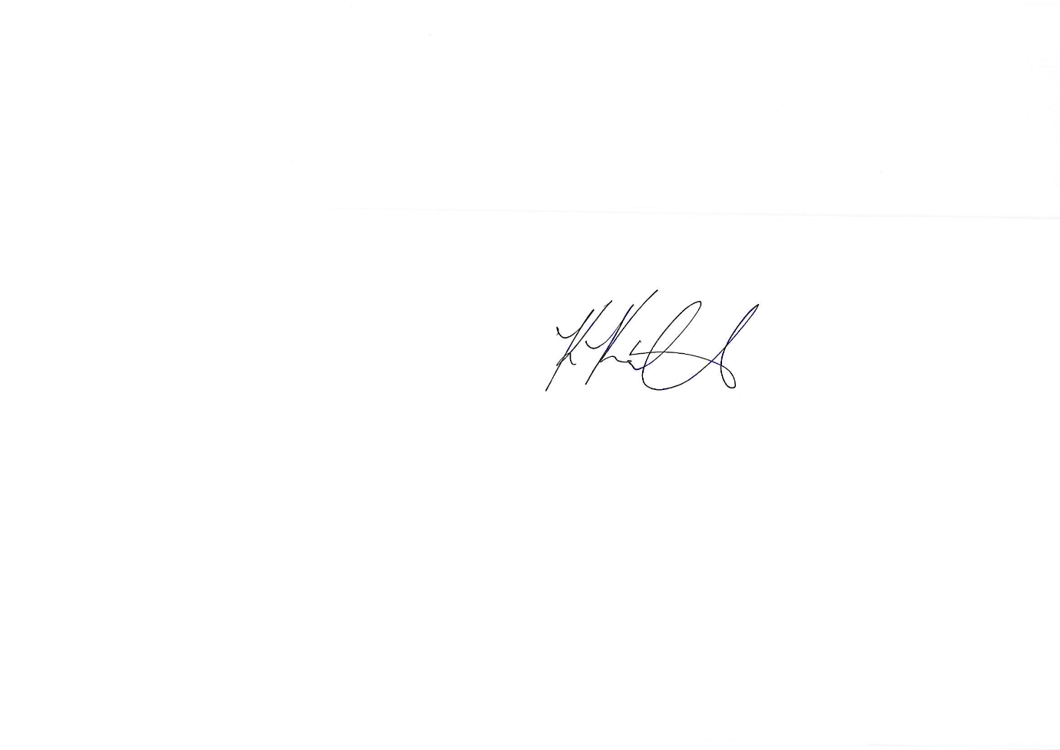

**Master Karl Kindred**

**MKMA Karate**

**6th Dan Black Belt**

**Chief Instructor / Deputy Safeguarding Lead**

**Mr James Rowberry**

**MKMA Karate**

**3rd Dan Black Belt**

**Chief Administrator**

**Designated Safeguarding Lead / Club Welfare Officer**

**MKMA Karate Instructor Application Checklist**

The below processes/qualifications do not need to be completed in any specific order although certain parts such as the instructor qualification will be inaccessible until you have been signed up to the BMABA.

|  |  |  |  |
| --- | --- | --- | --- |
|  | Comments | Cost  (May Vary) | Complete |
| BMABA Membership + Insurance | Will be applied for by MKMA Karate admin team, details sent to applicant on receipt of payment. | £99.99 |  |
| DBS | Details will be sent to you via email | £60.00 |  |
| Safeguarding | BMABA Safeguarding in Martial Arts (Available in the Qualifications and Training Section of your BMABA Account) | Inc. with BMABA account membership |  |
| First Aid | BMABA Martial Arts First Aid Award (Available in the Qualifications and Training Section of your BMABA Account) | Inc. with BMABA account membership |  |
| Instructor Level 1 | BMABA level one instructor Qualification (Available in the Qualifications and Training Section of your BMABA Account) | Inc. with BMABA account membership |  |

**Some Development Opportunities**

|  |  |  |
| --- | --- | --- |
| Coaching others to coach | <https://www.open.edu/openlearn/health-sports-psychology/coaching-others-coach/content-section-overview?active-tab=review-tab> | Free |
| Instructor Level 2 | BMABA level two instructor Qualification, **please contact the admin team before starting this course.** | Inc. with BMABA account membership |
| Prevent Training | [https://www.elearning.prevent.homeoffice.gov.uk/edu/screen1.html#](https://www.elearning.prevent.homeoffice.gov.uk/edu/screen1.html) | Free |

**MKMA Karate Policies Sign-Off Form**

Please Complete fully

|  |  |  |  |
| --- | --- | --- | --- |
| **Policy Name** | **Read**  **(Tick)** | **Understood (Tick)** | **Initials** |
| Safeguarding Children |  |  |  |
| Safeguarding Statement |  |  |  |
| Safeguarding Adults |  |  |  |
| Equality & Diversity |  |  |  |
| Whistle Blowing |  |  |  |
| Social Media |  |  |  |
| Disciplinary Policy |  |  |  |
| Complaints Procedure |  |  |  |
| Instructor Code of Conduct |  |  |  |
| Bullying |  |  |  |
| Health & Safety, Misc |  |  |  |
| GDPR |  |  |  |
| Safe Practice Guidelines |  |  |  |
| Instructor Qualifications &Training |  |  |  |
| Safe Recruitment |  |  |  |
| Photography & Use of Imagery |  |  |  |
| Events and Away Trips Guidance |  |  |  |

***Declaration***

*By completing the above table, I am demonstrating that I have read and understood all the necessary MKMA policies. I am aware that if I am in breech of any of the above polices or conduct myself in a manner which is below the standards expected from an MKMA instructor, my instructor status maybe withdrawn and reviewed.*

*I understand I am taking on a position of responsibility within the club and will endeavour to abide by all club rules and policies. I will ensure I keep my training up to date where required and will endeavour to participate in any opportunities offered to me or suggested to me by MKMA Karate.*

*I understand MKMA Karate holds the right to withdraw my instructor status at any time without prior notice. Should my instructor status be withdrawn, I understand I am no longer covered under my MKMA Instructors Insurance and should cease any Instruction activity immediately.*

**Applicant Name Date of Birth**

………………………………………………………………………… ……………………………………… **Signed Date**

………………………………………………………………………… ………………………………………

Office Use Only:

Instructor status approved: YES / NO (Delete as appropriate)

Signed:………………………………………………………………….. Date:………………………………..

Print Name:…………………………………………………… Position:……………………………………….

Assigned Instructor Number:……………………………….. Card Issue Date:……………………………..