**Complaints Procedure**

Master Kindred Martial Arts (MKMA Karate)

Written: 8th April 2021

Latest Review Date: July 2026

To Be Reviewed with Intervals No Greater Than 2 Years

**Reviewed last**: 30/07/2024

**Reviewed By:** J. Rowberry

**Signature:**

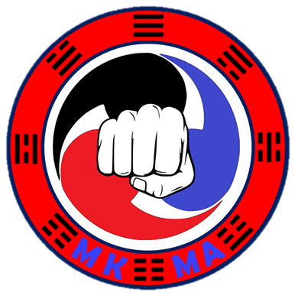

**Complaints Procedure**

MKMA Karate are committed to providing a high-quality service to all of our participants, children/young people, adults and parents/carers. When something goes wrong, we need you to tell us about it. This will help us to improve our standards.

If you have a formal complaint, please contact us using either email, message, or the contact us form found on the website. We will have up to 28 days to consider your complaint although aim to reply as soon as practical.

**What will happen next?**

1. We will send you a letter acknowledging receipt of your complaint within three days of receiving it, enclosing a copy of this procedure.
2. We will then investigate your complaint. This will normally involve passing your complaint to our chief/assistant chief instructor who will review your complaint and liaise with the instructor/admin team member who received the complaint.
3. We will then invite you to a meeting/contact you to discuss and hopefully resolve your complaint. we will do this within 14 days of sending you the acknowledgement letter.
4. If organised, within three days of the meeting we will write to you to confirm what took place and any solutions we have agreed with you.
5. If you do not want a meeting or it is not possible, we will send you a detailed written reply to your complaint, including suggestions for resolving the matter, within 21 days of sending you the acknowledgement letter.
6. At this stage, if you are still not satisfied, you should contact us again and we will arrange for someone unconnected with the matter, if possible, to discuss your complaint further.
7. We will write to you within 14 days of receiving your request for a review, confirming our final position on your complaint, and explaining our reasons.

**Useful Information**

**Email**: [mkmakarate@gmail.com](mailto:mkmakarate@gmail.com)

**Website**: [www.mkmakarate.co.uk](http://www.mkmakarate.co.uk)

**Phone**: 07734810941 / 07776192663

**Chief Instructor**: Master Karl Kindred

**Assistant Chief Instructor**: Master Sarah Martin

**Chief Administrator/Club Welfare Officer/Safeguarding Lead**: Mr James Rowberry