**Social Media**

**Policy and Procedures**

Master Kindred Martial Arts (MKMA Karate)

Written: 7th April 2021

Latest Review Date: July 2026

To Be Reviewed with Intervals No Greater Than 2 Years

**Reviewed last**: 30/07/2024

**Reviewed By:** J. Rowberry

**Signature:**

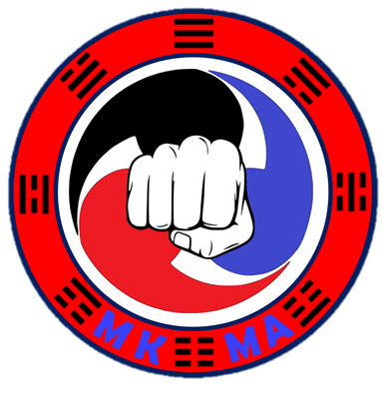

Social Media Policy

Social media (including personal and professional websites, blogs, chat rooms and bulletin boards; social networks, such as Facebook, LinkedIn, Twitter and Instagram; video-sharing sites such as YouTube) are a common means of communication and self-expression.

It’s essential that Instructors, members and parents/guardians make informed decisions about how they use the internet, mobile phone and email communications to protect our club and our people.

Everyone involved in our club has the responsibility to safeguard both in and out of the training hall, including communications.

It is the responsibility of all members to:

1. Refrain from publishing comments about other clubs, Students or Instructors and any controversial or potentially inflammatory subjects.

2. Avoid hostile or harassing communications in any posts or other online communications. Harassment is any offensive conduct based on a person`s race, sex, gender identity, national origin, colour, disability, age sexual orientation, veteran status, marital status, religion, or any other status protected by law.

3. Clubs should identify all copyrighted or borrowed material with citations and links. When publishing direct paraphrased quotes, thoughts, ideas, photos or videos, give credit to the original publisher or author.

4. The club will be responsible for reviewing responses to online posts and resolving any concerns.

5. If a blogger or any other online participant posts an inaccurate, accessory, or negative comment about your club or anyone associated with the club, do not reply but seek advice from the MKMA Admin team or Sport England.